3D object modeling



Name

**Amzad Hossain Rafi -1530520642**

Department of Electrical & Computer Engineering

North South University

Date

23/12/19

Cse299

**Instructor’s Name**

# **DR. MOHAMMAD ASHRAFUZZAMAN KHAN**

# Abstract

This project all about recreating any kind of solid object by generating coordinate distance and it will be store CSV format . In this project I use IR sensor to measure the distance between my sensor and the object in front of it . I use 2 nema 17 stepper motor and stepper driver to control the x-axis and z-axis rotation to cover the hole object in front of it . My sensor send 40 IR reading for every x-axis rotation till 200 or a full rotation and Arduno will make an average of the distance and it will print the avg coordinate into the text file in the memory card

from the generated text file we can easily import it to Math lab or Mash lab where we can easily recreate the original model by plotting the CSV file

# 

# Table of Contents

Table of Contents

Abstract 2

Table of Contents 3

List of Figure 4

1 Introduction 7

2 Background 8

2.1 Basic modeling 9

2.2 Curcite degine 10

2.3 problem I face ..................................................................................................................................10

3 Methodology 11

4 Basic architecture components.**........................................................................................12**

5 Conclusions and recommendations 14

6 References 16

# 

# List of Figures

Image 1 7

Image 2 8

Image 3 9

Image 4 9

Figure 1 10

Figure 2 (Head) 12

Figure 3 (coupler) 13

Figure 4 (base body) 13

Figure 5 (holder) 13

Figure 6 ( Carriage) 14

Figure 7 15

Figure 8 (volt to distance ) 16

# 1 Introduction

To print or make a 3D object, we first need the 3D image or design file. When we have the image or design file, we can print the object. In this project we will not make new 3D object. We will scan a 3D object to get a copy of 3D image or 3D design file which can be used to reprint or remake that object later. To do this we will make a machine using Arduino to scan 3D object.

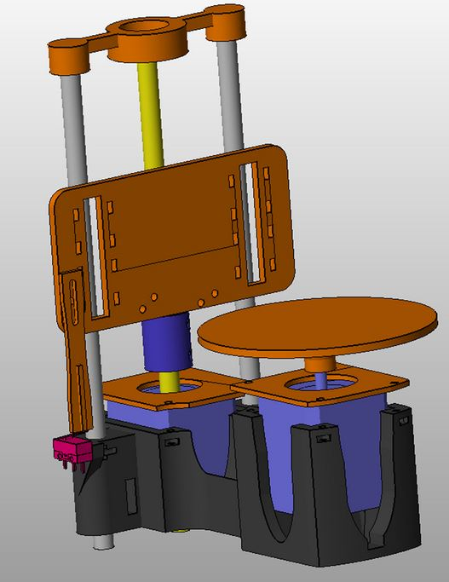

Image 1

Fig: Structure of the Machine

We have printed our 3D machine structure from <https://involutebd.com> , a 3D printing service shop located at Farmgate, Dhaka, Bangladesh. We went to them with our components and described our machine and they designed it in front of us and printed.

# Background

In this part I want to explain about back ground work of flow I did

## Base modeling

## At first thought the basic conseped of the base model so came up with some basic conseped of the base model there are mainly 3 main part of the model

1.x-axis rotation table

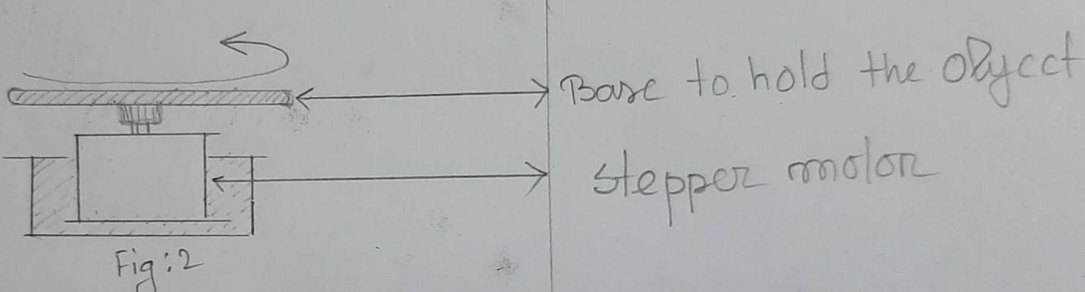

Image 2

2 .base body

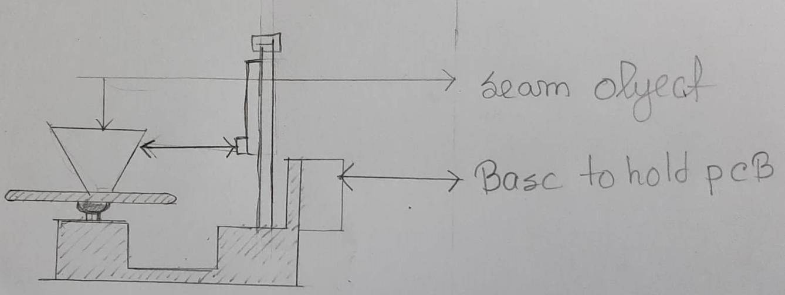

Image 3

3 .sensor holder and back mechanism

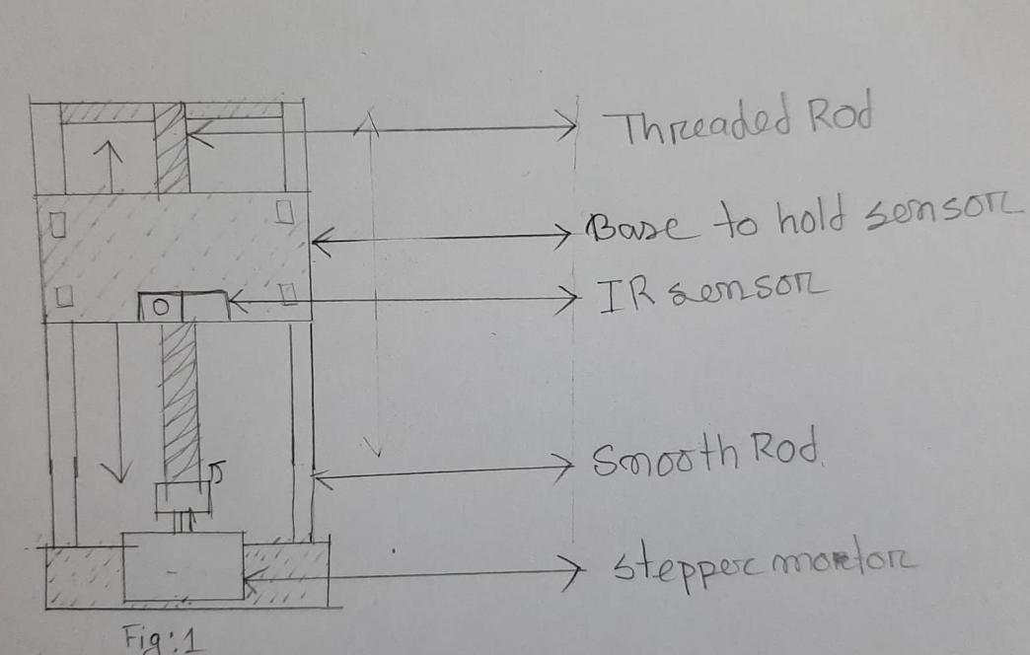

Image 4

All the basic component are created through AutoCAD software and given in the figure in below

* 1. **Circuit Diagram**

The next part is to design circuit . I design the ports of the arduino according to I program

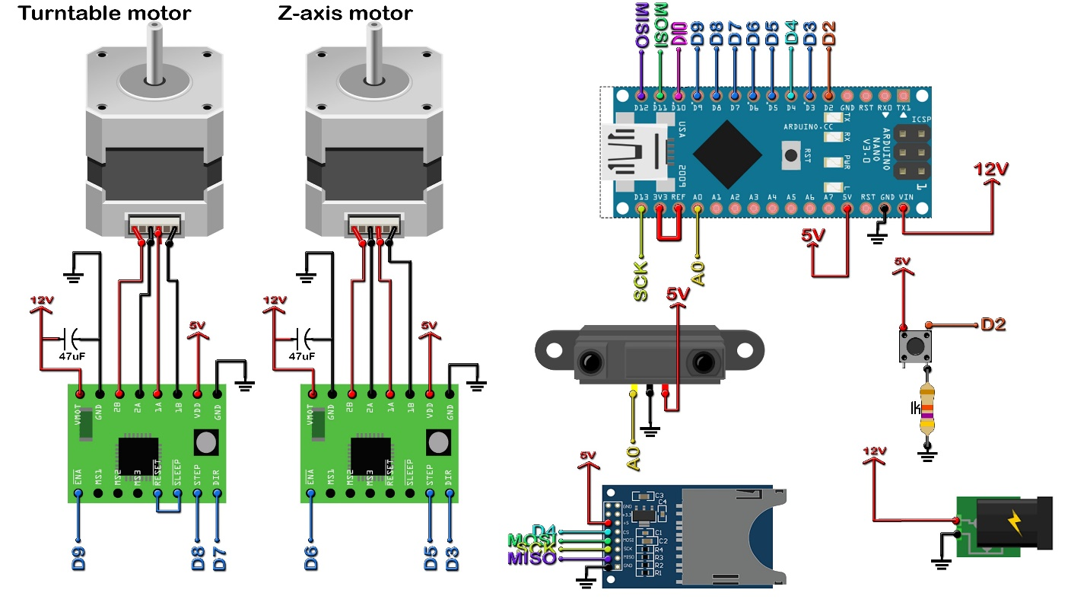

Figure 1

### 2.2.1 Problem I face

1.motor rotation problem

i find out my motor control drivers are not working properly

after 1 or 2 proper rotation

solution :

this problem was mainly happening because of the over heating of the

drivers i tried to encounter this problem in my program by adding a

delay(2000) method

2. maintain the level of vertical movement and step control of

the Y-axis stepper motor

because I have to make every level equal = 1 cm

solution :

I run through a simulation with Y-axis stepper motor

find out that for every 200 step or full Y-axisvertical movement is 2.2(+-) cm .so I reduce the the step

count to 100 step for rotation

# 3 Methodology

The push button is used to start the scanning process. We have connected Vref to 3.3V. Because maximum voltage of the sensor is 2.4V. To increase precision we use external voltage reference for thr Ac to DC conversion. We have connected all the components on a breadboard. There are two 47uF capacitors for each of the motor drivers.

This machine will be able to scan small 3D objects. We will place a small 3D object on a rotating table in its own axis. The table will rotate horizontally with the small 3D object on it by using a NEMA17 motor. Another NEMA17 motor will be used to move the IR sensor vertically while the table is rotating horizontally with the 3D object.

The distance between sensor and center of the turning table is 8cm. The turning table rotates 360/200 = 1.8 degree at a time to make 200 steps. The sensor measure the distance from the sensor to object point. If we subtract the measured distance from the distance between sensor and center of the turning table we get the distance between the object point and the center of the turning table. The IR sensor will give a direct analog output according to the measured distance between 0 and 1023. We can convert it to voltage by the following formula and then convert it to distance.

Voltage = (Analog Output * 3.3)/1023

Distance = -5.40274*pow(Voltage, 3) + 28.4823*pow(Voltage, 2) – 49.7115*Voltage + 31.3444

We found these formula from the datasheet of the sensor. The distance can be thought of as hypotenuse of a triangle. So

x = sin(1.8 degree) * Distance

y = cos(1.8 degree) * Distance

The z axis will be measured from 0 to 12 cm adding 2mm each time.

**4.Basic architecture components**

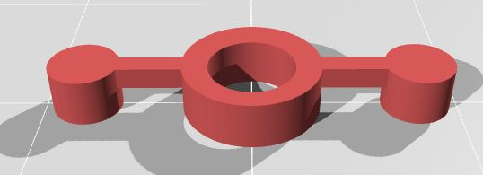

Figure 2 (Head)

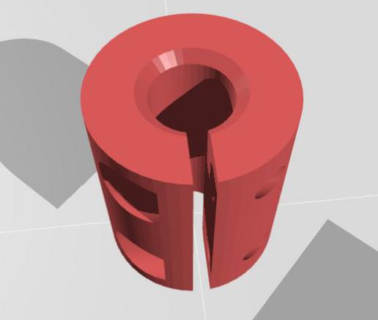

Figure 3(coupler)

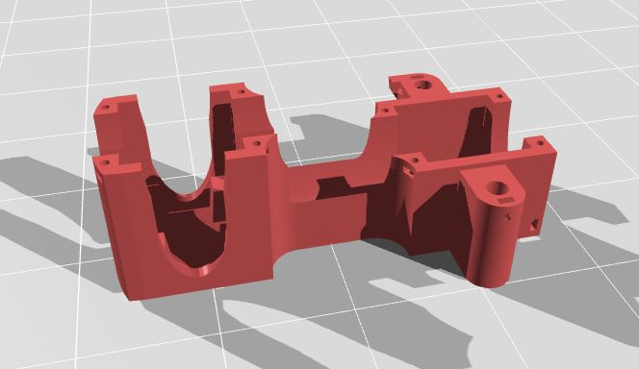

Figure 4(base body)

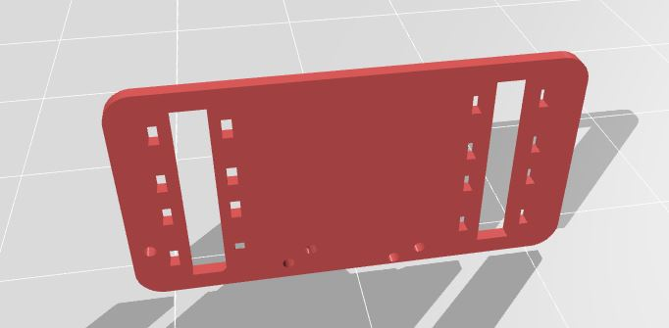

Figure 5(holder)

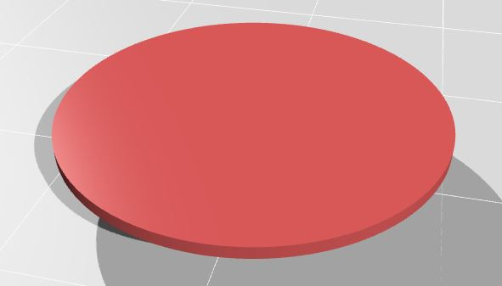

Figure 6( Carriage)

# 5 Results and discussion

The IR sensor will scan the 3D object during these motion and will save the data on a SD card. Four linear bearing, one threaded rod and two smooth rod will be used along with NEMA17 motor to move the IR sensor vertically. After completing the scanning we will remove the SD card and copy the text file of scanned data saved on SD card to a computer. We will import the text file in MESHLAB using MESHLAB we will generate the 3D image of the object in STL or OBJ format. Using that STL or OBJ file we can print the 3D object by a 3D printer..

# 

Figure 7

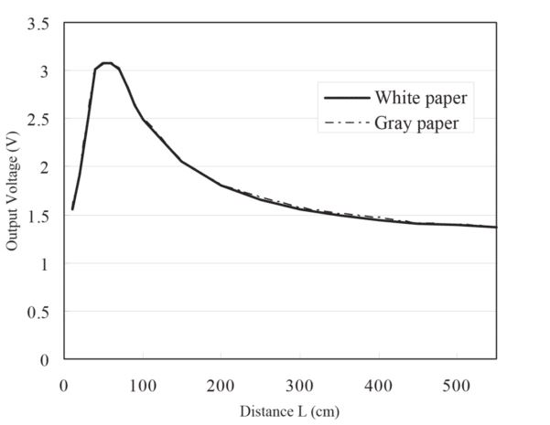

Figure 8(volt to distance )

# 5 Conclusions

Now a day 3d printing becoming more and more popular . In this project I tried to recreate the 3d printing technique with low cost by this anyone can recreate any object and model not only that anyone can remodel any object . It an fun project anyone do it

# 

# 6 References

I have to learn many thing about arduino around hole internet as I don’t have any basic knowledge about Arduino all the references links are given below

[1] <https://www.makerguides.com/sharp-gp2y0a710k0f-ir-distance-sensor-arduino-tutorial/> (IR sensor)

[2] <https://www.youtube.com/watch?v=0qwrnUeSpYQ> (stepper motor )

[3] <https://www.arduino.cc/en/tutorial/stepperSpeedControl> (stepper motor )

[4] <https://create.arduino.cc/projecthub/electropeak/sd-card-module-with-arduino-how-to-read-write-data-37f390>(SD card )

[5]

<https://www.youtube.com/watch?v=d8_xXNcGYgo&list=PLGs0VKk2DiYx6CMdOQR_hmJ2NbB4mZQn->(arduino tutorial )

[6] <https://www.youtube.com/watch?v=sS_oW81NweI> (sd card module connection )